Annual Crime Report
2014 & 2015

A Summary of Crime in Harrow

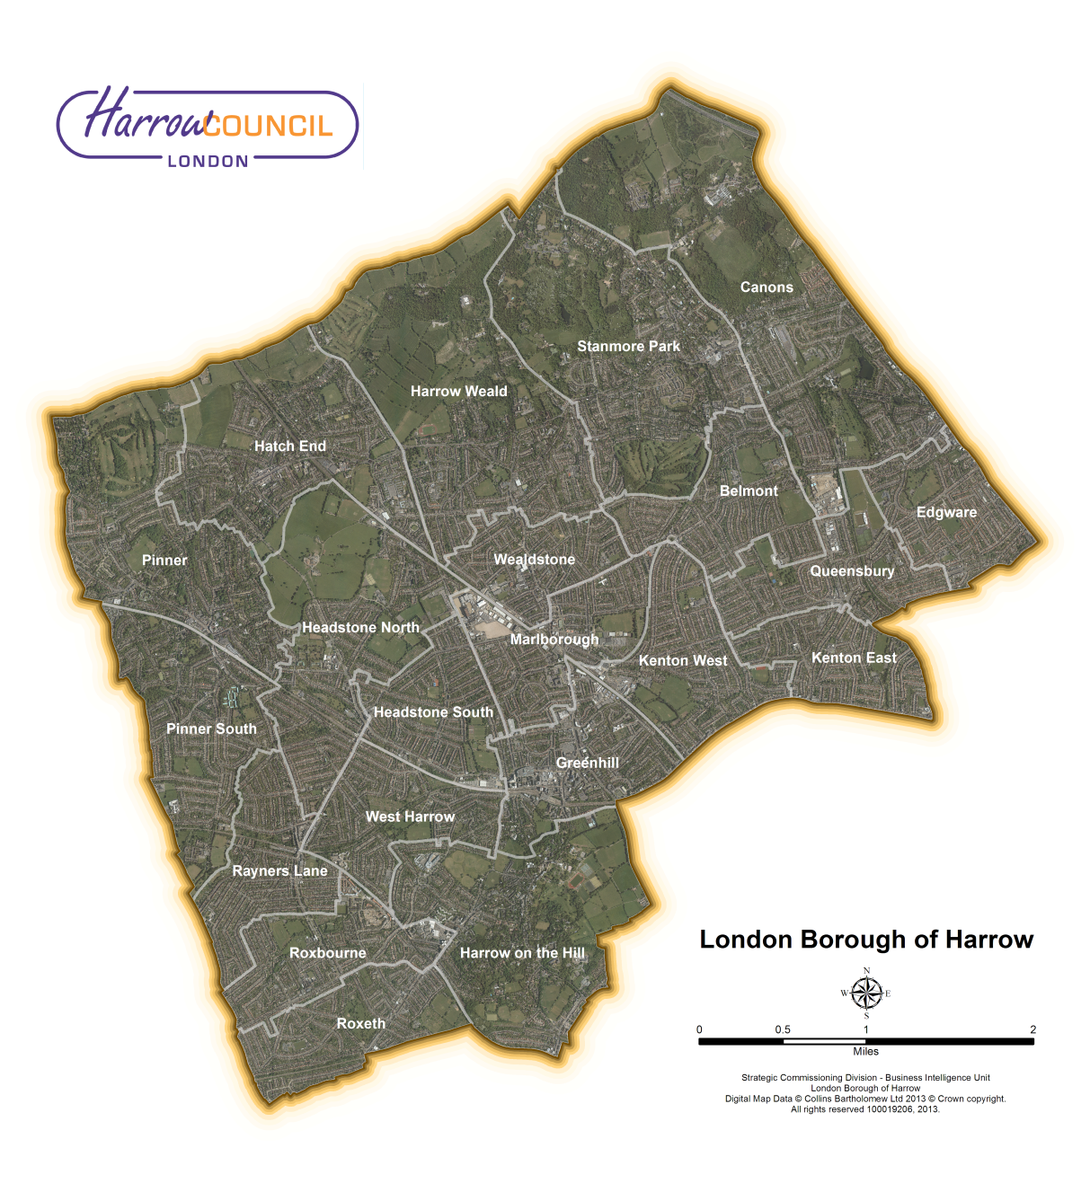

Harrow Council, Station Road, Harrow, HA1 2XY
Strategic Commissioning Division - Business Intelligence Unit

Harrow Annual Crime Report 2014 & 2015

Title: | Safer Harrow Annual Crime Report
Purpose: | Planning for Community Safer Strategy
Relevant to: | Safer Harrow Management Group
Authors: | Harrow Council - Business Intelligence Unit
Date Created: | December 2015

Acknowledgements
- Senior Leadership Team, Harrow Police
- Metropolitan Police – http://maps.met.police.uk/tables.htm
  - Data extract: December 2015

Copyright

All maps used within this report are reproduced from the Ordnance Survey mapping with permission of the Controller of her Majesty’s Stationery Office © Crown Copyright 100019206. Unauthorised reproduction infringes Crown Copyright and may lead to prosecution or civil proceedings.

All other maps are courtesy of Digital map Data © Collins Bartholomew LTD (2015) & Harrow Strategic Assessment 2008 through 2015.

Purpose

Safer Harrow refers to the Community Safety Partnership that was set up following the 1998 Crime and Disorder Act with the aim of promoting a multi-agency approach to reducing crime and anti-social behaviour. Safer Harrow comprises the Police, Harrow Council, the Primary Care Trust, London Probation, London Fire Brigade, Trading Standards and the voluntary sector.

Crime rates were based on ONS Mid-year Population Estimates from June 2015:

  - Harrow: 243,400 (2013) and 246,000 (2014)
  - Greater London: 8,409,100 (2013) and 8,530,700 (2014)

Time periods:

- October 2013 through September 2014
- October 2014 through September 2015

Table of Contents
Harrow Annual Crime Report 2014 & 2015 2
Acknowledgements 2
Copyright 2
Purpose 2
Table of Contents 3
Level of total crime in Harrow & Greater London 4
Change in the level of crime in Harrow & Greater London 5
MOPAC 7 Crimes in Greater London 6
MOPAC Crimes in Greater London 7
MOPAC Crimes in Harrow - Latest 24 months (October 2013 through September 2015) 8
Violence with Injury 9
Robbery 10
Burglary 11
Theft of a Motor Vehicle 12
Theft from a Motor Vehicle 13
Theft from a Person 14
Criminal Damage 15

Level of total crime in Harrow & Greater London

The total of recorded offences during Period 2 (October 2014 - September 2015) for Greater London was 713,137. The total of recorded offences during Period 1 (October 2013 - September 2014) for Greater London was 686,565. This represents a 3.9% increase or 26,572 more crimes in period 2 over period 1.

In Harrow, a total of 12,367 crimes was recorded during Period 2, which was 1.73% of all crime reported in Greater London. This was the fifth lowest of actual crimes reported. When this total is divided by Harrow’s population the resulting crime rate is 50.3 crimes per 1,000 population. This gives Harrow the second lowest crime rate in London..
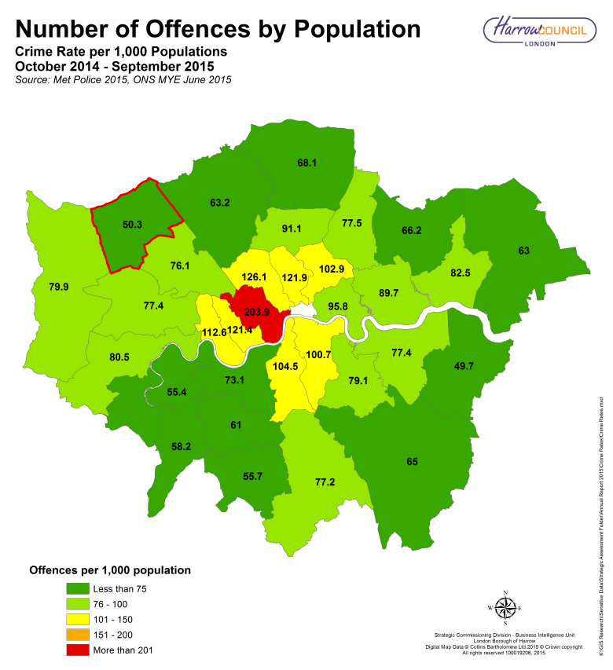
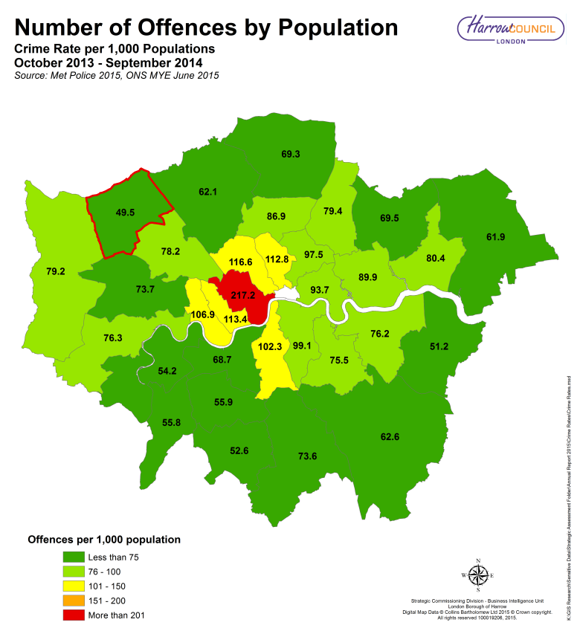

Greater London
686,565
Total Crimes – Period 1
Greater London
713,137
Total Crimes – Period 2
26,572
More Crimes

Greater London
81.6
Crimes per 1,000 populations
Greater London
83.6
Crimes per 1,000 populations
2.5%
More crimes per 1,000 Population

Change in the level of crime in Harrow & Greater London

The total number of all crimes in Harrow in Period 2 increased by 2.6% (12,053 to 12,367), compared to Period 1. This is lower than Greater London’s 3.9% increase as a whole.
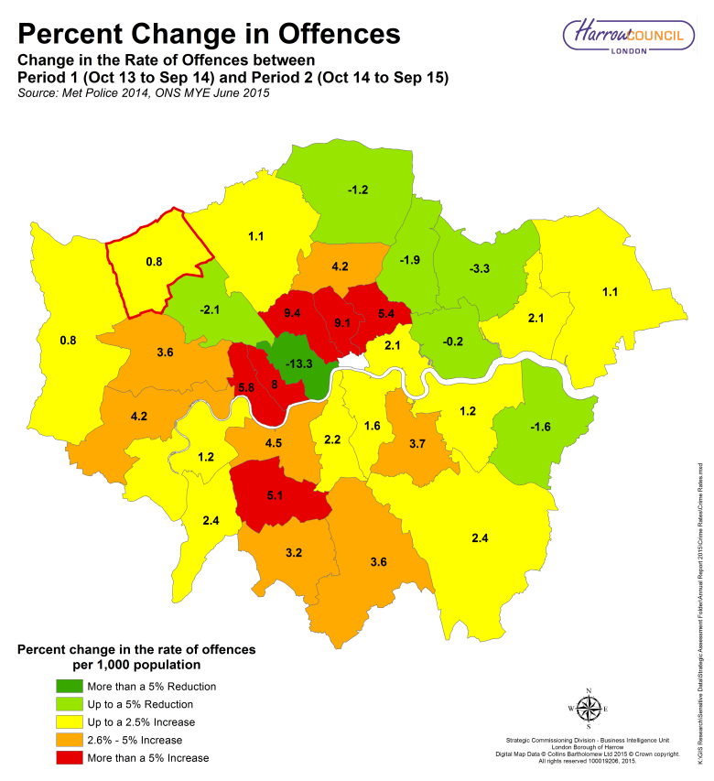
When comparing with Harrow’s neighbouring boroughs; Brent has shown the greatest reduction in the crime rate between the two time periods, while Hillingdon showed a similar increase to Harrow. Barnet’s increase was slightly higher than Harrow’s while Ealing recorded the largest increase in the area.
LB Harrow
49.5
Crimes per 1,000
populations in Period 1

LB Harrow 0.8%
Higher

LB Harrow
50.3
Crimes per 1,000
populations in Period 2

Borough | Previous * | Current * | Change * |  | Borough | Previous * | Current * | Change *
Barking and Dagenham | 80.4 | 82.5 | 2.1 |  | Hounslow | 76.3 | 80.5 | 4.2
Barnet | 62.1 | 63.2 | 1.1 |  | Islington | 112.8 | 121.9 | 9.1
Bexley | 51.2 | 49.7 | -1.6 |  | Kensington and Chelsea | 113.4 | 121.4 | 8.0
Brent | 78.2 | 76.1 | -2.1 |  | Kingston upon Thames | 55.8 | 58.2 | 2.4
Bromley | 62.6 | 65.0 | 2.4 |  | Lambeth | 102.3 | 104.5 | 2.2
Camden | 116.6 | 126.1 | 9.4 |  | Lewisham | 75.5 | 79.1 | 3.7
Croydon | 73.6 | 77.2 | 3.6 |  | Merton | 55.9 | 61.0 | 5.1
Ealing | 73.7 | 77.4 | 3.6 |  | Newham | 89.9 | 89.7 | -0.2
Enfield | 69.3 | 68.1 | -1.2 |  | Redbridge | 69.5 | 66.2 | -3.3
Greenwich | 76.2 | 77.4 | 1.2 |  | Richmond upon Thames | 54.2 | 55.4 | 1.2
Hackney | 97.5 | 102.9 | 5.4 |  | Southwark | 99.1 | 100.7 | 1.6
Hammersmith and Fulham | 106.9 | 112.6 | 5.8 |  | Sutton | 52.6 | 55.7 | 3.2
Haringey | 86.9 | 91.1 | 4.2 |  | Tower Hamlets | 93.7 | 95.8 | 2.1
Harrow | 49.5 | 50.3 | 0.8 |  | Waltham Forest | 79.4 | 77.5 | -1.9
Havering | 61.9 | 63.0 | 1.1 |  | Wandsworth | 68.7 | 73.1 | 4.5
Hillingdon | 79.2 | 79.9 | 0.8 |  | Westminster | 217.2 | 203.9 | -13.3

* Previous - Crime rates based on offences from October 2013 through September 2014 with ONS Mid -Year Estimates from June 2015.
* Current - Crime rates based on offences from October 2014 through September 2015 with ONS Mid-Year Estimates from June 2015.
* Change - The percent change based on the two time periods.

MOPAC 7 Crimes in Greater London

There were 329,450 MOPAC 7 offences reported throughout Greater London during Period 2 (October 2014 through September 2015) giving a rate of 38.6 crimes per 1,000 populations. This was a reduction of 2.5% from the 333,114 MOPAC 7 crimes committed during time Period 1 (October 2013 through September 2014) at a rate of 39.6 crimes per 1,000 populations.

In Harrow, a total of 5,910 MOPAC 7 crimes were recorded during Period 2, which was 1.8% of all MOPAC 7 crimes reported in Greater London. This was the fifth lowest number of crimes reported giving Harrow a rate of 24.0 MOPAC 7 crimes per 1,000 population. Harrow had the third lowest MOPAC 7 recorded crime rate, behind Kinston upon Thames and Bexley.
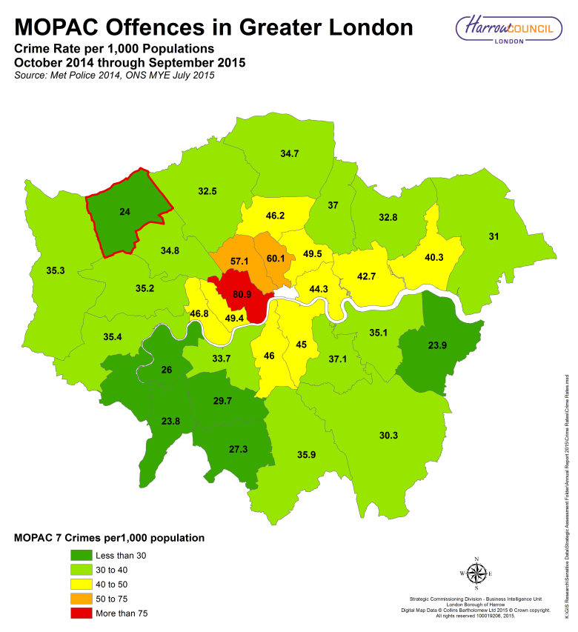
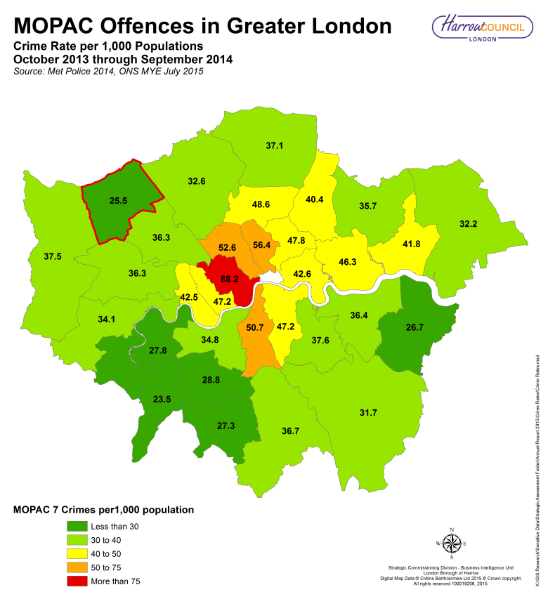

Greater London
38.6
MOPAC Crimes per 1,000 populations in Period 2
Greater London
39.6
MOPAC Crimes per 1,000 populations in Period 1
Greater London
2.5%
Lower

LB Harrow
25.5
MOPAC Crimes per 1,000 populations in Period 1
LB Harrow
24.0
MOPAC Crimes per 1,000 populations in Period 2
LB Harrow 5.9%
Lower

MOPAC Crimes in Greater London
Below are the MOPAC Crime totals and rates per 1,000 populations from the latest 12 month period (October 2014 through September 2015 - Period 2).

Borough | Violence with Injury |  | Robbery |  | Burglary |  | Theft of a  Motor Vehicle |  | Theft from a  Motor Vehicle |  | Theft from Person |  | Criminal Damage |  | MOPAC Totals
 | Figures | Rate | Figures | Rate | Figures | Rate | Figures | Rate | Figures | Rate | Figures | Rate | Figures | Rate | Figures | Rate
Barking and Dagenham | 2,075 | 10.5 | 539 | 2.7 | 1,701 | 8.6 | 707 | 3.6 | 950 | 4.8 | 299 | 1.5 | 1,730 | 8.7 | 8,001 | 40.3
Barnet | 2,085 | 5.6 | 630 | 1.7 | 3,647 | 9.7 | 648 | 1.7 | 2,343 | 6.2 | 617 | 1.6 | 2,202 | 5.9 | 12,172 | 32.5
Bexley | 1,288 | 5.4 | 179 | 0.7 | 1,122 | 4.7 | 548 | 2.3 | 920 | 3.8 | 128 | 0.5 | 1,549 | 6.5 | 5,734 | 23.9
Brent | 2,751 | 8.6 | 781 | 2.4 | 2,645 | 8.2 | 738 | 2.3 | 1,451 | 4.5 | 660 | 2.1 | 2,151 | 6.7 | 11,177 | 34.8
Bromley | 2,002 | 6.2 | 363 | 1.1 | 2,464 | 7.7 | 770 | 2.4 | 1,527 | 4.8 | 262 | 0.8 | 2,342 | 7.3 | 9,730 | 30.3
Camden | 2,202 | 9.4 | 1,050 | 4.5 | 2,827 | 12.0 | 789 | 3.4 | 1,496 | 6.4 | 3,187 | 13.6 | 1,861 | 7.9 | 13,412 | 57.1
Croydon | 3,336 | 8.9 | 746 | 2.0 | 2,919 | 7.8 | 903 | 2.4 | 2,013 | 5.4 | 494 | 1.3 | 3,098 | 8.2 | 13,509 | 35.9
Ealing | 2,689 | 7.9 | 629 | 1.8 | 2,772 | 8.1 | 717 | 2.1 | 2,280 | 6.7 | 548 | 1.6 | 2,424 | 7.1 | 12,059 | 35.2
Enfield | 2,338 | 7.2 | 858 | 2.6 | 2,812 | 8.7 | 632 | 1.9 | 2,070 | 6.4 | 444 | 1.4 | 2,123 | 6.5 | 11,277 | 34.7
Greenwich | 2,453 | 9.1 | 471 | 1.8 | 1,933 | 7.2 | 629 | 2.3 | 1,267 | 4.7 | 474 | 1.8 | 2,197 | 8.2 | 9,424 | 35.1
Hackney | 2,761 | 10.5 | 1,024 | 3.9 | 2,359 | 9.0 | 583 | 2.2 | 1,711 | 6.5 | 2,464 | 9.4 | 2,126 | 8.1 | 13,028 | 49.5
Hammersmith and Fulham | 1,672 | 9.4 | 394 | 2.2 | 1,536 | 8.6 | 618 | 3.5 | 1,833 | 10.3 | 814 | 4.6 | 1,477 | 8.3 | 8,344 | 46.8
Haringey | 2,649 | 9.9 | 1,183 | 4.4 | 2,641 | 9.9 | 788 | 2.9 | 1,807 | 6.8 | 1,147 | 4.3 | 2,133 | 8.0 | 12,348 | 46.2
Harrow | 1,313 | 5.3 | 318 | 1.3 | 1,581 | 6.4 | 193 | 0.8 | 1,061 | 4.3 | 277 | 1.1 | 1,167 | 4.7 | 5,910 | 24.0
Havering | 1,624 | 6.6 | 361 | 1.5 | 1,944 | 7.9 | 752 | 3.1 | 1,054 | 4.3 | 317 | 1.3 | 1,584 | 6.4 | 7,636 | 31.0
Hillingdon | 2,352 | 8.0 | 340 | 1.2 | 2,469 | 8.4 | 552 | 1.9 | 1,950 | 6.7 | 392 | 1.3 | 2,290 | 7.8 | 10,345 | 35.3
Hounslow | 2,170 | 8.2 | 399 | 1.5 | 1,799 | 6.8 | 482 | 1.8 | 1,991 | 7.5 | 443 | 1.7 | 2,122 | 8.0 | 9,406 | 35.4
Islington | 2,203 | 10.0 | 997 | 4.5 | 2,310 | 10.5 | 809 | 3.7 | 1,299 | 5.9 | 3,653 | 16.5 | 2,016 | 9.1 | 13,287 | 60.1
Kensington and Chelsea | 1,248 | 8.0 | 409 | 2.6 | 1,563 | 10.0 | 752 | 4.8 | 1,426 | 9.1 | 1,264 | 8.1 | 1,047 | 6.7 | 7,709 | 49.4
Kingston upon Thames | 1,025 | 6.0 | 92 | 0.5 | 943 | 5.5 | 137 | 0.8 | 485 | 2.9 | 330 | 1.9 | 1,026 | 6.0 | 4,038 | 23.8
Lambeth | 3,431 | 10.8 | 1,217 | 3.8 | 2,604 | 8.2 | 898 | 2.8 | 1,952 | 6.1 | 1,903 | 6.0 | 2,636 | 8.3 | 14,641 | 46.0
Lewisham | 2,623 | 9.0 | 806 | 2.8 | 2,087 | 7.1 | 831 | 2.8 | 1,559 | 5.3 | 506 | 1.7 | 2,425 | 8.3 | 10,837 | 37.1
Merton | 1,241 | 6.1 | 269 | 1.3 | 1,545 | 7.6 | 390 | 1.9 | 923 | 4.5 | 250 | 1.2 | 1,428 | 7.0 | 6,046 | 29.7
Newham | 3,214 | 9.9 | 1,445 | 4.5 | 2,185 | 6.7 | 916 | 2.8 | 2,322 | 7.2 | 1,434 | 4.4 | 2,335 | 7.2 | 13,851 | 42.7
Redbridge | 1,935 | 6.6 | 653 | 2.2 | 2,435 | 8.3 | 823 | 2.8 | 1,623 | 5.5 | 512 | 1.7 | 1,637 | 5.6 | 9,618 | 32.8
Richmond upon Thames | 846 | 4.4 | 144 | 0.7 | 1,547 | 8.0 | 358 | 1.8 | 882 | 4.6 | 179 | 0.9 | 1,072 | 5.5 | 5,028 | 26.0
Southwark | 2,990 | 9.9 | 1,266 | 4.2 | 2,913 | 9.6 | 880 | 2.9 | 1,602 | 5.3 | 1,434 | 4.7 | 2,524 | 8.3 | 13,609 | 45.0
Sutton | 1,248 | 6.3 | 181 | 0.9 | 1,380 | 7.0 | 267 | 1.3 | 802 | 4.0 | 152 | 0.8 | 1,376 | 6.9 | 5,406 | 27.3
Tower Hamlets | 2,822 | 9.9 | 1,130 | 4.0 | 2,342 | 8.2 | 978 | 3.4 | 1,527 | 5.4 | 1,359 | 4.8 | 2,425 | 8.5 | 12,583 | 44.3
Waltham Forest | 2,352 | 8.8 | 692 | 2.6 | 2,198 | 8.2 | 713 | 2.7 | 1,596 | 6.0 | 547 | 2.0 | 1,817 | 6.8 | 9,915 | 37.0
Wandsworth | 2,218 | 7.1 | 459 | 1.5 | 2,483 | 8.0 | 1,042 | 3.3 | 1,742 | 5.6 | 686 | 2.2 | 1,877 | 6.0 | 10,507 | 33.7
Westminster | 3,189 | 13.7 | 1,501 | 6.4 | 3,244 | 13.9 | 852 | 3.7 | 2,001 | 8.6 | 6,060 | 26.0 | 2,016 | 8.6 | 18,863 | 80.9
Greater London Totals: | 70,345 | 8.2 | 21,526 | 2.5 | 70,950 | 8.3 | 21,695 | 2.5 | 49,465 | 5.8 | 33,236 | 3.9 | 62,233 | 7.3 | 329,450 | 38.6

MOPAC Crimes in Harrow - Latest 24 months (October 2013 through September 2015)

All figures stated below were taken from the MET Police website that was available at the end of November 2015.

Violence with Injury
10.4%
Higher
This includes a range of offences such as Murder, Wounding / GBH and Assault with Injury.

There was a total number of 1,313 offences during Period 2, which is up from the Period 1. This translates to a 10.4% increase or 124 additional offences in Period 2. The chart below also shows the number of offences in boroughs around Harrow and in Greater London.

Violence with Injury | Period 1 - Previous |  | Period 2 - Current |  | Offences Change
 | Offences | Rate | Offences | Rate
Harrow | 1,189 | 4.9 | 1,313 | 5.3 | +10.4
Barnet | 1,846 | 5.0 | 2,085 | 5.6 | +12.9
Brent | 2,562 | 8.1 | 2,751 | 8.6 | +7.4
Ealing | 2,491 | 7.3 | 2,689 | 7.9 | +7.9
Hillingdon | 2,216 | 7.7 | 2,352 | 8.0 | +6.1
Greater London | 64,135 | 7.6 | 70,345 | 8.2 | +9.7

The chart below shows the number of offences recorded in Harrow during each month for Period 1 in orange and Period 2 in purple.
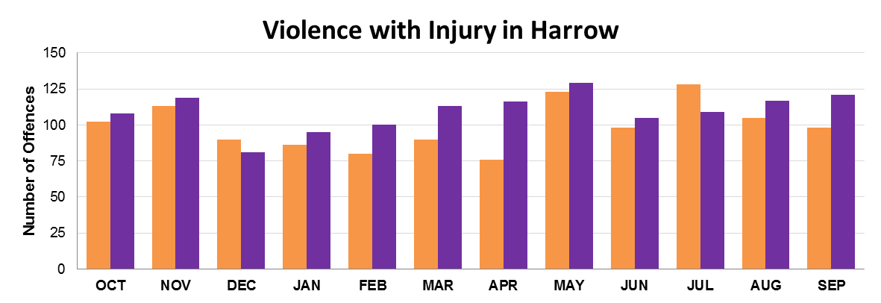

The following chart shows the change in crime from Period 1 in each London Borough. Harrow has an average increase in Violence with Injury within Greater London.

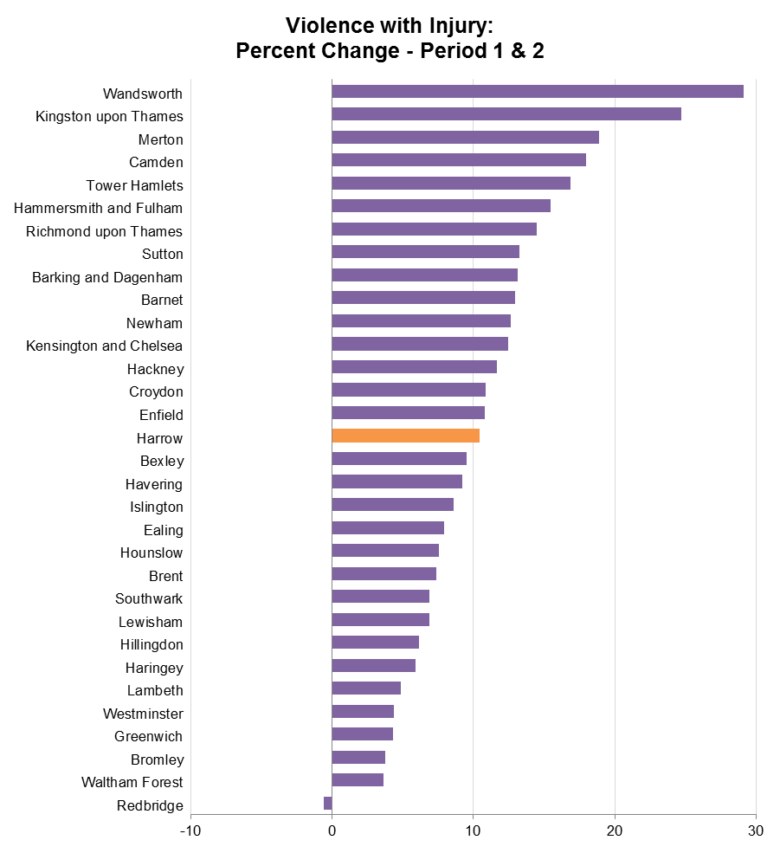

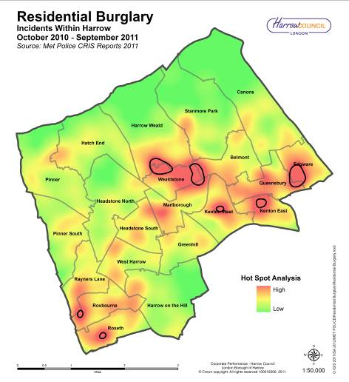
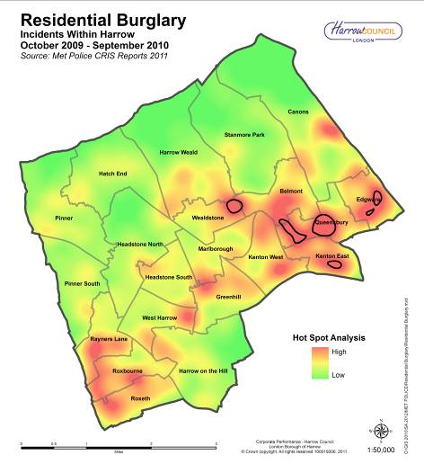

Robbery

This includes crimes such as theft with the use of force or a threat of force. Personal robberies, commercial robberies and snatch are also included.
5.3%
Higher

There was a total of 318 offences during Period 2, which is an increase from Period 1. This translates to a 5.3% increase or 16 additional offences in Period 2. The chart below also shows the number of offences in neighbouring boroughs and in Greater London.

Robbery | Period 1 - Previous |  | Period 2 - Current |  | Offences Change
 | Offences | Rate | Offences | Rate
Harrow | 302 | 1.2 | 318 | 1.3 | +5.3
Barnet | 613 | 1.7 | 630 | 1.7 | +2.8
Brent | 945 | 3.0 | 781 | 2.4 | -17.4
Ealing | 690 | 2.0 | 629 | 1.8 | -8.8
Hillingdon | 515 | 1.8 | 340 | 1.2 | -34.0
Greater London | 23,330 | 2.8 | 21,526 | 2.5 | -7.7

The chart below shows the number of offences recorded in Harrow during each month for Period 1 in orange and Period 2 in purple.
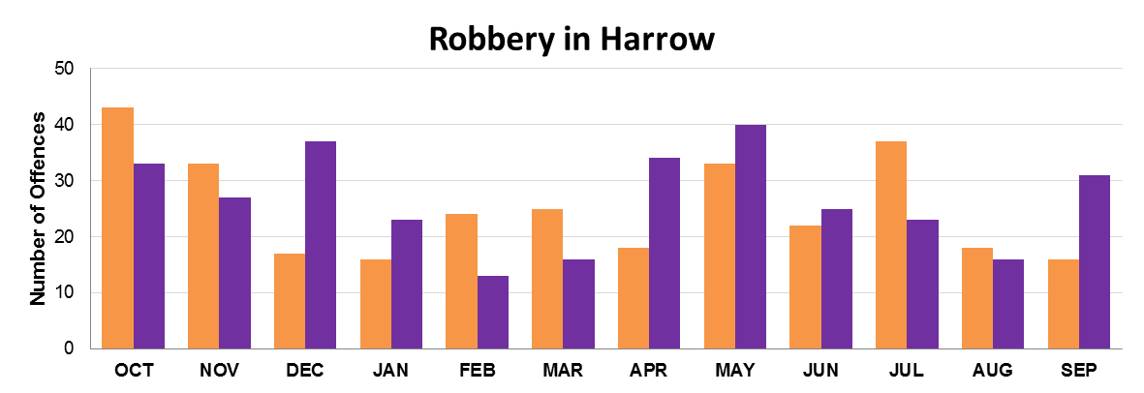

The following chart shows the change in crime from Period 1 and Period 2 by each London Borough. Harrow has recorded an increase but it was to the lower end of the boroughs with any increase within Greater London. More than half of boroughs saw a decrease in robbery between Periods 1 and 2

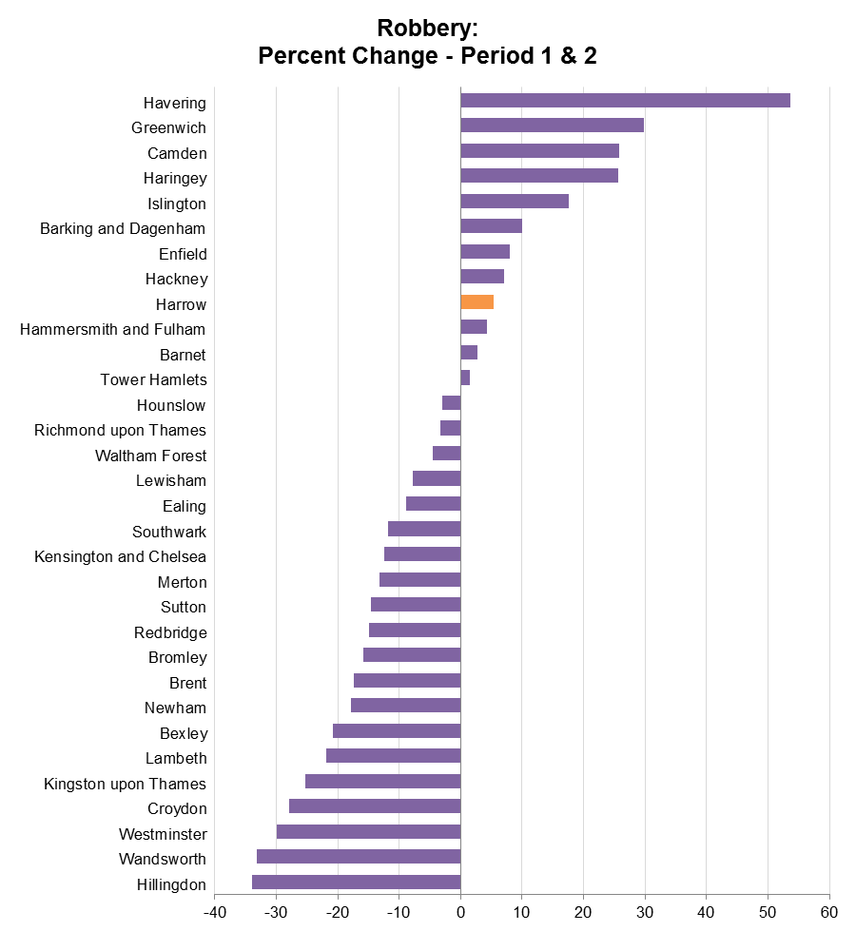

Burglary
14.1%Lower
This includes the theft, or attempted theft, from a residential or commercial building/premises where access is not authorised. Damage to a building/premises that appears to have been caused by a person attempting to enter to commit a burglary, is also counted as burglary.

There was a total of 1,581 offences during Period 2, which is down from Period 1. This translates to a 14.1% decrease or 259 fewer offences in Period 2. The chart below also shows the number of offences in boroughs around Harrow and in Greater London.

Burglary | Period 1 - Previous |  | Period 2 - Current |  | Offences Change
 | Offences | Rate | Offences | Rate
Harrow | 1,840 | 7.6 | 1,581 | 6.4 | -14.1
Barnet | 3,772 | 10.2 | 3,647 | 9.7 | -3.3
Brent | 2,697 | 8.5 | 2,645 | 8.2 | -1.9
Ealing | 2,929 | 8.6 | 2,772 | 8.1 | -5.4
Hillingdon | 2,672 | 9.3 | 2,469 | 8.4 | -7.6
Greater London | 78,874 | 9.4 | 70,950 | 8.3 | -10.0

The chart below shows the number of offences recorded in Harrow during each month for Period 1 in orange and Period 2 in purple.
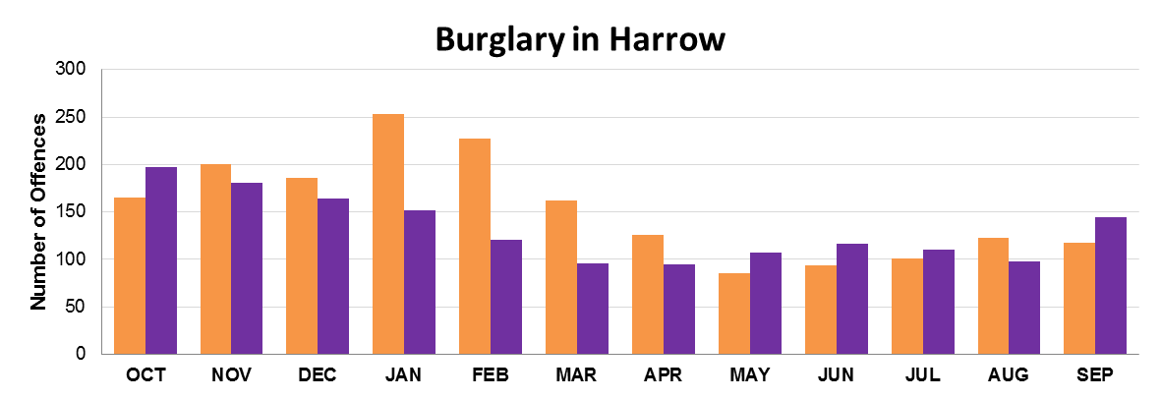

The following chart shows the change in crime from Period 1 and Period 2 by each London Borough. Harrow has shown an impressive reduction in burglary within Greater London.

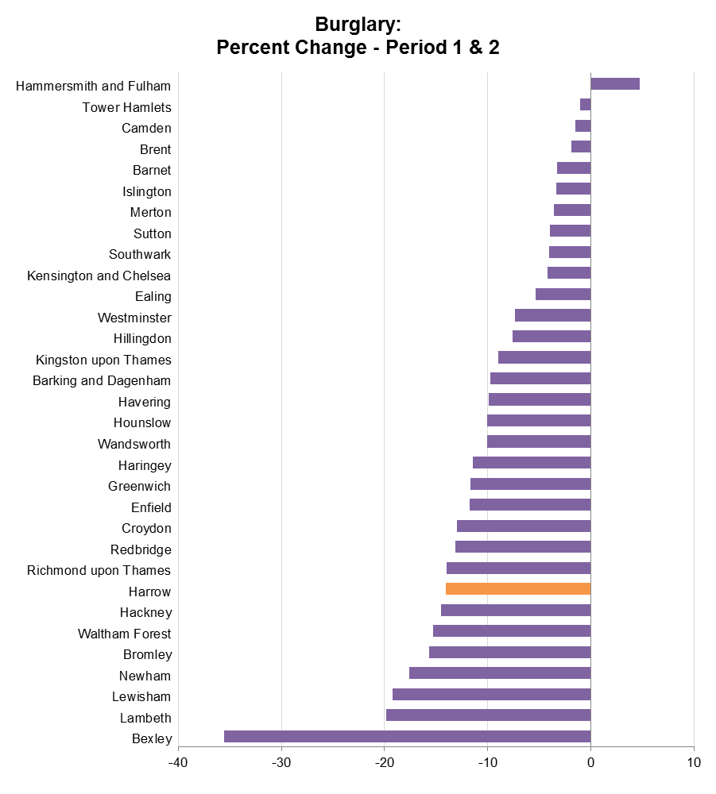

Theft of a Motor Vehicle

This includes the theft / taking of a motor vehicle or a similar type of motor vehicle.
3.2%
Higher

There was a total of 193 offences during Period 2, which is up from the previous Period. This translates to a 3.2% increase or 6 additional offences in Period 2. The chart below also shows the number of offences in boroughs around Harrow and in Greater London.

Theft of a  Motor Vehicle | Period 1 - Previous |  | Period 2 - Current |  | Offences Change
 | Offences | Rate | Offences | Rate
Harrow | 187 | 0.8 | 193 | 0.8 | +3.2
Barnet | 758 | 2.1 | 648 | 1.7 | -14.5
Brent | 651 | 2.1 | 738 | 2.3 | +13.4
Ealing | 701 | 2.0 | 717 | 2.1 | +2.3
Hillingdon | 508 | 1.8 | 552 | 1.9 | +8.7
Greater London | 21,216 | 2.5 | 21,695 | 2.5 | +2.3

The chart below shows the number of offences recorded in Harrow during each month for Period 1 in orange and Period 2 in purple.
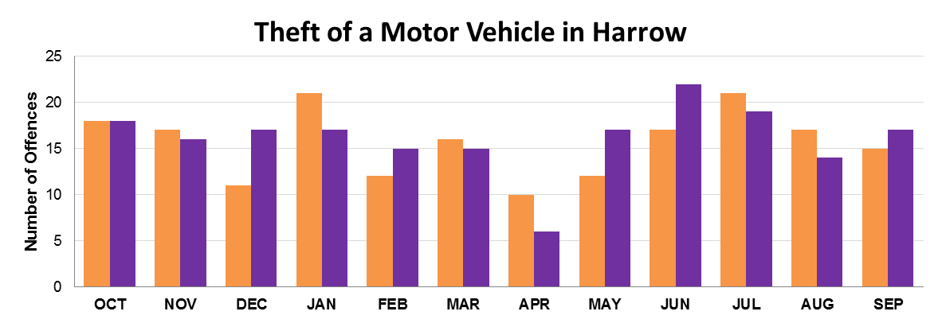

The following chart shows the change in crime from Period 1 and Period 2 by each London Borough. Harrow has shown a small increase in a theft of a motor vehicle within Greater London.

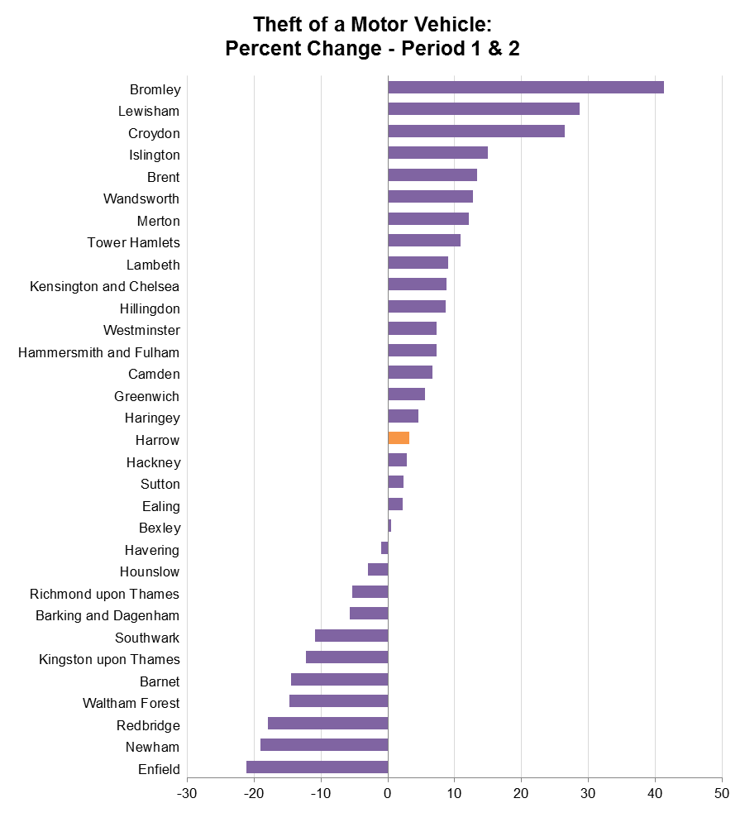

Theft from a Motor Vehicle
13.7%Lower
This includes theft of an item or object from a Motor Vehicle.

There was a total of 1,061 offences during Period 2, which is down from the Period 1. This translates to a 13.7% decrease or 168 fewer offences in Period 2. The chart below also shows the number of offences in boroughs around Harrow and in Greater London.

Theft from a  Motor Vehicle | Period 1 - Previous |  | Period 2 - Current |  | Offences Change
 | Offences | Rate | Offences | Rate
Harrow | 1,229 | 5.0 | 1,061 | 4.3 | -13.7
Barnet | 2,413 | 6.5 | 2,343 | 6.2 | -2.9
Brent | 1,829 | 5.8 | 1,451 | 4.5 | -20.7
Ealing | 2,766 | 8.1 | 2,280 | 6.7 | -17.6
Hillingdon | 2,078 | 7.2 | 1,950 | 6.7 | -6.2
Greater London | 55,831 | 6.6 | 49,465 | 5.8 | -11.4

The chart below shows the number of offences recorded in Harrow during each month for Period 1 in orange and Period 2 in purple.
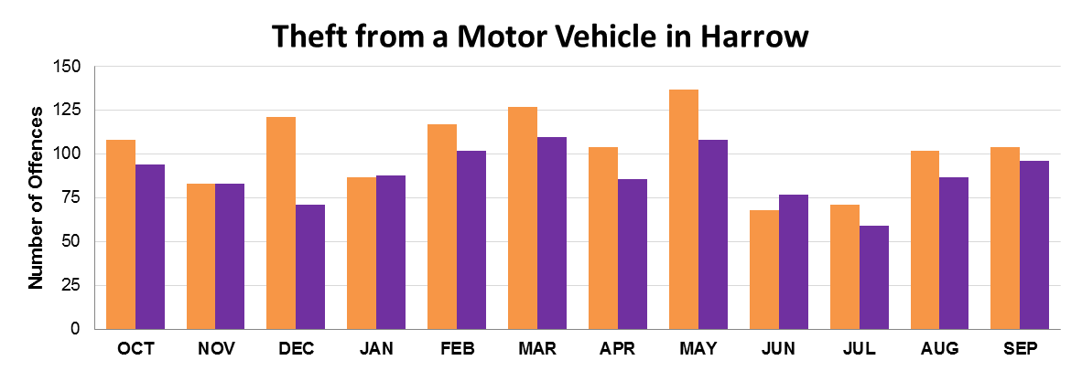

The following chart shows the change in crime from Period 1 and Period 2 by each London Borough. Harrow has shown a good reduction in theft from a motor vehicle within Greater London.

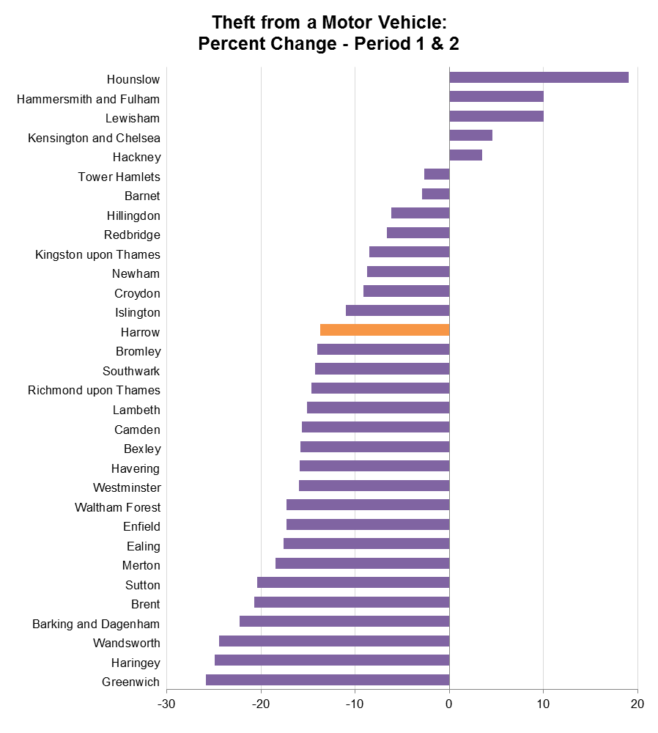

Theft from a Person
11.2%Lower
This includes theft from a person, pickpocket and other theft.

There was a total of 277 offences during Period 2, which is down from Period 1. This translates to a 11.2% decrease or 35 fewer offences in Period 2. The chart below also shows the number of offences in boroughs around Harrow and in Greater London.

Theft from a Person | Period 1 - Previous |  | Period 2 - Current |  | Offences Change
 | Offences | Rate | Offences | Rate
Harrow | 312 | 1.3 | 277 | 1.1 | -11.2
Barnet | 637 | 1.7 | 617 | 1.6 | -3.1
Brent | 777 | 2.4 | 660 | 2.1 | -15.1
Ealing | 609 | 1.8 | 548 | 1.6 | -10.0
Hillingdon | 451 | 1.6 | 392 | 1.3 | -13.1
Greater London | 32,647 | 3.9 | 33,236 | 3.9 | +1.8

The chart below shows the number of offences recorded in Harrow during each month for Period 1 in orange and Period 2 in purple.
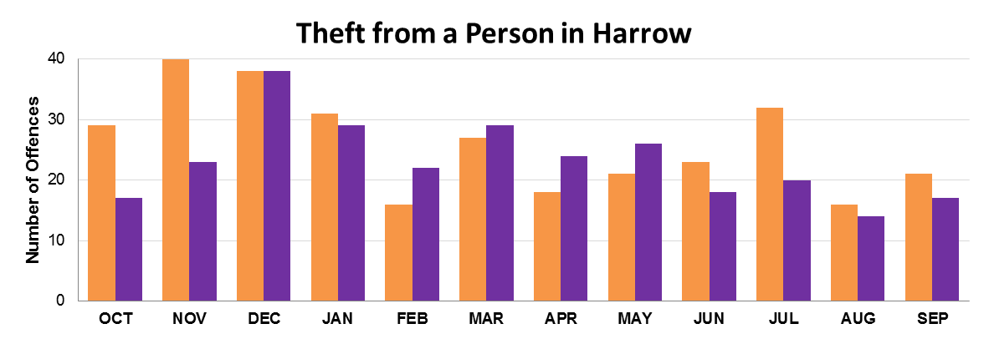

The following chart shows the change in crime from Period 1 and Period 2 by each London Borough. Harrow has shown some of the lowest decreases of theft from a person within Greater London.

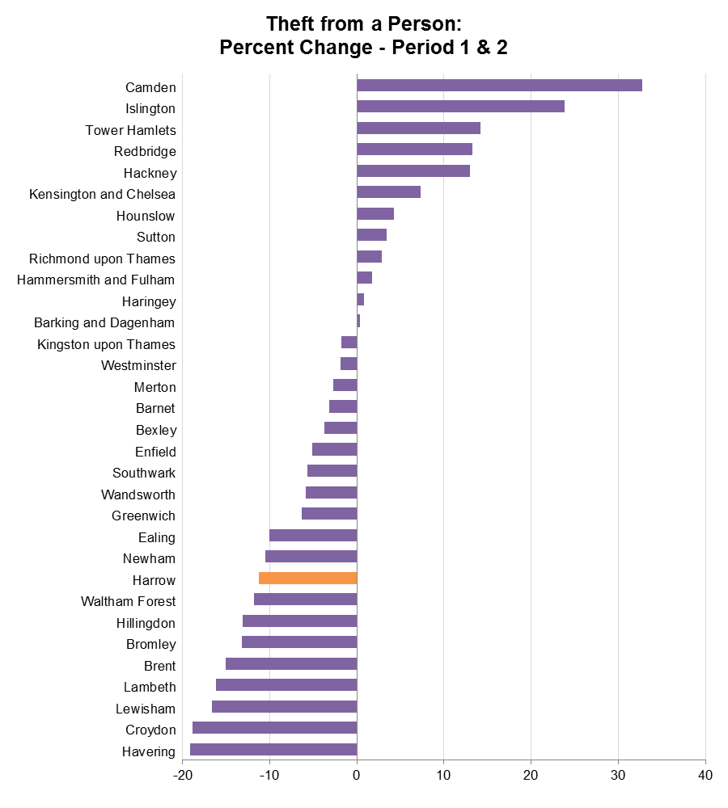

Criminal Damage
1.2%
Higher
This includes offences such as damage to a dwelling, damage to other buildings, damage to a motor vehicle and other criminal damage offences.

There was a total of 1,167 offences during Period 2, which is up from Period 1. This translates to a 1.2% increase or 14 additional offences in Period 2. The chart below also shows the number of offences in boroughs around Harrow and in Greater London.

Criminal Damage | Period 1 - Previous |  | Period 2 - Current |  | Offences Change
 | Offences | Rate | Offences | Rate
Harrow | 1,153 | 4.7 | 1,167 | 4.7 | +1.2
Barnet | 1,991 | 5.4 | 2,202 | 5.9 | +10.6
Brent | 2,064 | 6.5 | 2,151 | 6.7 | +4.2
Ealing | 2,247 | 6.6 | 2,424 | 7.1 | +7.9
Hillingdon | 2,305 | 8.0 | 2,290 | 7.8 | -0.7
Greater London | 57,081 | 6.8 | 62,233 | 7.3 | +9.0

The chart below shows the number of offences recorded in Harrow during each month for Period 1 in orange and Period 2 in purple.
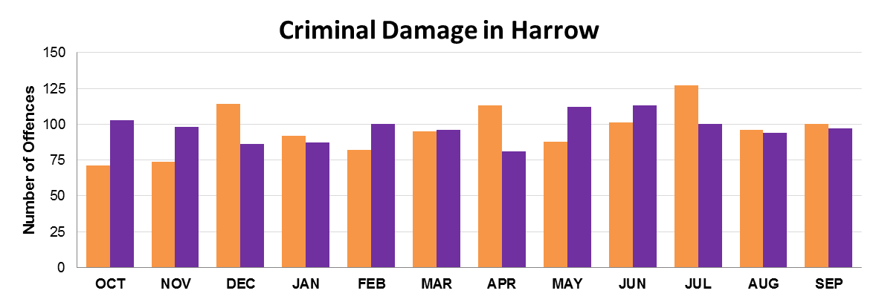

The following chart shows the change in crime from Period 1 and Period 2 by each London Borough. Harrow has shown the lowest increase in criminal damage within Greater London.

